Elizabethtown College Wellness Center Design

Cal Graziano, Brynne Kirsch, Sarah Fay
Elizabethtown College, Elizabethtown, PA 17022
EGR343 Green Architectural Engineering
Fall 2014

ABSTRACT

Elizabethtown College has set forth a goal to not only expand their campus and facilities, but to integrate mind, body, and spirit amongst all members of it’s community. The collaboration of the college, its resources, its faculty, and its students has led to the creation of the Elizabethtown College Wellness Center Design project. This project, tasked to the students of Elizabethtown College’s EGR343 Green Architectural Engineering class, intends to innovate potential design elements, create conceivable computer automated designs, promote discussion, and make a push toward incorporating a potential wellness center on campus. A project created by the college, for the college; the Wellness Center Design truly embodies the intentions and goals of the college as a whole.
Our group, accompanied with our knowledge of green architectural engineering design, comprehension of engineering principles, and understanding of Elizabethtown College from a current student’s perspective, has set forth and produced a model that satisfies the needs of the client, incorporates sustainable building design, and creates a plausible, creative, and harmonious center for students. The result is a thorough proposal toward the prospective implementation of the Elizabethtown College Wellness Center. This paper aims to showcase all of the valuable elements in the design, and provides further comprehension to the reader on the basis of the project.

I. INTRODUCTION

The preliminary goals and guidelines of the project were generated through discussion between the college leaders and designated project spearheads, and were presented to the EGR343 Green Architectural Engineering class courtesy of Dean of Students, Dean Calenda. While generally broad in terms of encompassing the total project, these guidelines dictated our production and integration of the wellness center. The requests and guidelines given to us, as well as the respective requested square footage of each element are shown in Table I, presented in Appendix 1.
Additionally, the project was designed with certain imperative objectives in mind. The produced proposal was aimed to draw focus on and embody the following goals:

- Integration of mind, body, and spirit
- Promote unity of students, faculty, and staff
- Promote unity of athletics, academics, and student services
- Sustainability
- Wellness across culture and beliefs
- Possibility of allowing outside community
- Balance clear identities with acceptance of others

These project goals are continuously touched upon through the basis of this paper, and our efforts to implement all of them are explained concisely when describing each design element of the project. These project goals, coupled with the requested amenities provided by our clients, dictate our project, as the total design is shaped around these underlying project principles.

II. SITE SELECTION

Our project design began with where our wellness center would be located. Several aspects had to be kept in mind during the site selection process. Stern and equivalent consideration was placed on the following two factors: what site provided us with a practical amount of space to integrate all of our desired design elements and amenities, and how accessible would our design site be. Both of these factors drew upon the project goals of promoting unity of students, faculty, and staff, promoting unity of athletics, academics, and student services, and allowing outside community. An ideal site creates a central hub in order to unify the campus, and can also allow outside community without disrupting the compact, private nature of the campus. Our site had to be the optimal location in order to appease the majority of these needs.
In terms of the Elizabethtown College campus, land expansion in places outside of the current campus boundaries seemed dubious and counterintuitive to our design. The campus currently is suitably tight-knit for the type of college it aims to be, and expanding outside of campus would compromise that structure. However, the growth of the college in the past in terms of additional buildings and structures has led to the depletion of accessible open space within the current boundaries. Due to both of these factors, we were limited right away in our ability to choose a site location. The only suitable locations on campus that allowed practical space for our project, in order of site size, were Brinser field, the practice fields directly next to the turf field, and the land allotted above the varsity soccer field, where the softball field currently is.
Already having narrowed down plausible site locations due to space limitations, we weighed each of these options according to the project goals that applied to the site selection. In order to comprehensively view the advantages one site had over another, a Pugh table was created, labeled as Table II and presented in Appendix 2, comparing each potential new site with the baseline current site being Thompson Gymnasium. The Pugh table uses the aforementioned project goals, as well as additional criteria, to measure the value of each site.
Additional weight was added to the traits found most valuable to the purpose of the project. The weight given to the first criteria, unity of students, faculty, and staff, was interpreted as how easily accessible the site would be to all three of these parties. This aims at placing the site at a central hub that would sufficiently connect the dorms (students), academic and coach’s offices (faculty), and the current student center (staff). Brinser field easily scored higher than the other two options on the list due to its central location on campus, however, when compared the baseline site of Thompson Gymnasium, it was valued the same due to their relatively similar locations.
Unity of athletics, academics, and student services was another weighted criteria, as it was another premier goal of the project. The scoring of this category was based upon the ability of the site to connect practice fields, game fields, and locker rooms (athletics), academic buildings and places of study (academics), and the location of both existing and prospective student services. This was viewed differently than the first criteria, because when grading this, we viewed the ability to combine the new athletic, academic, and student service facilities implemented in our prospective project with the pre-existing athletic, academic, and student service facilities. For instance, a plus was given to site 3 in this category because prospective learning services, places of study, and athletic facilities created in our project would help to expand the realm in which these activities take place on campus. Academic study and student services would be in the same location as an athletic hub, creating a healthy coexistence between all parties.
Weight given to minimal natural destruction and expansion criteria ties into our project goal of maintaining sustainability. The site that requires the least land expansion, being destruction of preexisting nature, flattening of land, etc., scored highest.
The highest weight was given to the final criteria, space allotted in terms of square footage. The only guidelines given to us by our client were the inclusion of certain requested facilities, while no other restrictions were specified. Meeting the needs of the client is the most vital component of the project, especially when such extra freedom is granted. Without the necessary space to place our project, it is impossible to meet the client’s demands.
The remaining criterion was found important but not exceedingly vital to the project. Those scores are relatively self-explanatory.
Through the Pugh Table process, we determined the optimal location of our wellness center that complied with our most essential goals. Site 3, the location of the current varsity softball field above the varsity soccer field, scored the highest of all the sites, and was chosen to be our site selection. The outline of the square footage required, as well as the placement and orientation of the site is shown in Appendix A.

A. Accessibility
One of the downfalls of the site selection, and one that must be addressed, is the negative score Site 3 received under “ease of accessibility,” as shown in Table II. To attempt to place a “unifying wellness hub” outside the range of easy accessibility is to set your project up for hypocritical condemnation. This issue was obvious to us, and we chose to solve it instead of make students accept it. The solution came in the form of a campus wide bike system.
By providing students with bikes, it further motivates and inclines the student body as a whole to do the following: use more environmentally friendly transportation to get from one point to another, stay more active, and explore parts of campus they previously might have been discouraged to visit, such as athletic fields and facilities on the outskirts of campus. Additionally, there are several biking trails within a one-mile vicinity of campus that the bikes could be useful for.
The idea of incorporating a bike rental system on college campuses is a great notion, which is why it isn’t a new one. These ideas are already being implemented on campuses across the country, which is why we were able to do these campus bike experiments one better. The evident downfalls of bike rental systems on college campuses are that they’re located on college campuses. A select minority that exists on every college campus across America has potential to ruin the bike rental system for the rest of the students. College students will wreak havoc when given the chance, and in the form of bikes that aren’t theirs, this means vandalism, destruction, and even disappearances of bikes.
The solution, and what we offer to implement in our design, is a card swipe system. Bikes are placed on a locked rack, and in order to sign one out, a student must swipe their ID card into a readable device connected to the bike rack. When that student’s card is verified, the bike rack unlocks the nearest bike, and the student is allowed to use that bike for a set time, say 2-3 hours. Additionally, when the student returns a bike, they swipe their card again and a slot in the bike rack opens up and allows the student to lock the bike back into place. Bike racks would be located at key locations around campus, including the wellness centers, to allow pick up at one location and drop off at another. This system deems responsibility for lost or damaged bikes, and assesses fines for anything from late fees to bikes stolen completely.

III. ATHLETIC FIELD RELOCATION

One of the negative aspects of the site selection is the necessity of rearranging certain athletic fields. The chosen site, Site 3, interferes with the pre-existing varsity softball field, as well as the quad soccer practice field. Both of these sites must be relocated in order to lay the foundation, and create enough suitable space for the wellness center. The present outline of the current practice and varsity fields is shown in Appendix B.
The objective of the field relocation is to displace the fields that the wellness center compromises, while still keeping in mind the underlying goals of the project as a whole. The relative objectives that influence the field relocation involve unifying athletics, academics, and student services, as well as maintaining sustainability. By displacing the fields an extended distance away from the location of the wellness center, it defeats the purpose of attempting to unify athletics, academics, and student services, and unravels the effort made to accomplish that through the site selection. Additionally, sustainability becomes an issue when dealing with expanding acreage on campus to make room for these new field locations. Expansion can mean natural destruction, thus rescinding the original environmental objective of the project.
By rearranging some additional fields, and placing the displaced fields where they can fit, it’s possible to maintain the current number of fields provided by the campus while both installing the proposed wellness center and avoiding any additional expansion. The full Athletic Field Relocation Plan is detailed in Appendix C. All field locations shown in the appendix photos are the same sizes as when they were in their original locations.

IV. DESIGN

With our spatial organization and designated square footage finalized, we began to assess our ability to incorporate the requested guidelines and facilities, while also focusing on our project goal focus points. As previously established, the clients requests were our top priority, so we analyzed what features we might be able to include according to what was reasonable in terms of funding, size, construction time, and magnitude.
One of the first points noted about the project was the vagueness of the request, and the freedom of design accompanied by that. The clients request a large array of features, but don’t specify the allotted funding, or the overall importance they wish the project to have on campus. Both of these factors affect willingness to carry through with a proposed design, as many proposals may contain the specific demands made by the client, but are just not plausible in terms of being too large, too grand, or too preposterous. Our group took the approach of keeping our feet on the ground, but our head in the clouds; remaining practical, yet imaginative and visionary at the same time.
This approach led to the creation of the “Add-On Process.” The process begins with a starting point: a basic, minimalistic design that is less strenuous and more practical to incorporate but lacks some of the requested facilities. It’s a starting point in the Add-On Process, which, as the name entitles, is a process of building off, or adding on to, an original design in order to expand facilities easily and without another massive constructive effort. The Add-On Process gives the clients both options and flexibility, as they are able to assess their limitations and then move forward accordingly. The following proposed designs can be implemented in stages, or, if possible, the client can jump straight to the final design stage and implement it all in one construction process.

A. Design One: Basic Design
Our design starting point, Design One, is the main core of our wellness center design. With the possibility of either standing alone, or being the starting block to possible additions, we designed Design One to be able to do both sufficiently. The design is centered above the varsity soccer field, and extends straight backwards toward the varsity baseball field. The figure presented in Appendix J, Fig. 1, illustrates the size and orientation of the design.
An immediate, necessary action with the placement of this design deals with the fact that the land the proposed design lays on is not already established and ready for construction. While the front, where the varsity softball field currently lies, is established land, the back half of the design lays on what is now elevated forestry. This land must be leveled and cleared of any foliage before construction begins. This downfall was an aforementioned negative aspect of the site selection, however does not present a heavily problematic issue. The land to be deforested is arid and barren woodland, where most of the vegetation has decayed past a returnable healthy state. Additionally, the land is neither exceptionally dry, nor wet, and can therefor be easily flattened. These factors combined show that the deforestation expansion taking place is not excessively detrimental to our sustainability goal, nor does it compromise the site location as being unsuitable to lay a foundation.
Design One, despite being the starting point of our Add-On Process, includes the majority of the requested facilities. A comprehensive list of the facilities Design One contains, the square footage of each of these facilities, and a side-by-side comparison of the requested facilities and accompanied square footage is shown in Appendix D. Furthermore, the floor plan for Design One, including labels of each specified room, is provided in Appendix E. Each facility and room either meets the requested square footage, or exceeds it. As for requested facilities and rooms without a designated required square footage, spatial estimations were made, and were generally overestimated to ensure we provided enough area to properly carry out the functions of that room or space. The additional space that is not addressed in Appendix D, including hallways, restrooms, and lobbies, is addressed in Appendix F.

a. Amenities
The following amenities are more clearly comprehended while following the floor plan provided in Appendix E. This subsection provides detailed explanations of all the provided rooms, facilities, and amenities as they are listed in Appendix D.
The major focal point of Design One is the inclusion of an NCAA regulated 200-meter indoor track. This requested element of the wellness center was the central and most important aspect of our base design for two reasons. The structure enclosing the track area is referred to as the main fieldhouse. Its roof is 30’ tall at its lowest point and 40’ tall at it’s highest.
The first deals with the shear size of a 200-meter indoor track, and the difficulty of installation that comes with a component that takes up so much square footage. Had the track not been the central focal point, it would have been a confusing add-on, not to mention an overshadowing one at that. The track and additional seating space itself take up more than half of the Design One square footage.
Secondly, the track ranks especially high in importance of components requested by our clients. It was made clear that the track was a major necessity for the clients, as it was the first amenity listed on the requested guideline provided. Moreover, we personally assessed the importance of each requested element and decided that a NCAA regulated track was the utmost important element on the list. The majority of year round sports are provided with their own personal training grounds for the athletic season they participate in, yet one sport lacks this. Of all the winter sports included within Elizabethtown College athletics, Winter Track & Field is the only outdoors sport. Harsh outdoor winter conditions means the Track & Field team is often left to scrounge around and utilize whatever spare indoor space is apportioned to them, most of the time being the hallways surrounding Thompson Gymnasium. The necessity to house all Elizabethtown athletic programs is reason enough to prioritize an indoor track, but even more positives accompany this mindset. With a new NCAA regulation indoor track, Elizabethtown College could become a premier hub for indoor Track & Field meets, ranging from simple dual or tri team meets to Conference or Regional events. This draws not only massive amounts of positive attention toward Elizabethtown College, but business and profitability in terms of food or merchandise sold, and possible entry fees for larger events.
The eight requested locker rooms, laundry and equipment rooms, trainer facility, as well as public restrooms are included in a one story high extension of the fieldhouse. This extension is constructed to share one wall with the main field house, however it has it’s own roof and additional walls, as it scales the exterior bottom half of the fieldhouse. The public restrooms are located purposely in close proximity to the side lobbies, as they should be located as close to the main entrances as possible. Laundry rooms are located so that athletes must pass by them both before and after they enter and leave their respective locker room. This is due to the fact that athletes pick up and drop off their laundry “loops” before and after every practice and game, making the laundry room positioning a convenient location for them. The doubling of laundry rooms and public bathrooms conveniently accompanies both “sections” of locker rooms, and doesn’t require athletes or visitors to go out of their way to reach their destination. Additionally, the trainer facility is located at the very bottom of the wellness center, in between both locker room sections, so that it is equally as accessible for the locker rooms on the right as it is for the locker rooms on the left.
There are three main entrance points to access the wellness center, and respectively, there are three lobbies to provide entrances: two side lobbies and one front lobby. The two side lobbies are positioned as optimal entrance points for students and visitors. The left-side lobby is less than 10 feet away from a preexisting walking path that already leads students directly from the apartments and the Founders dorms to the location of the wellness center. The right-side lobby is not only conveniently faced toward the Quads, but also allows for the construction of a spacious parking area on that side of the building for visitors, students, faculty, and staff alike. Both lobbies contain a receptionist desk with intentions of requiring mandatory check-in, and small cafés toward the back wall with seating scattered around the café. The front lobby, while less practical than the two side lobbies, acts as more of a showcase area for the wellness center. It overlooks the varsity soccer field, and by creating a transition from the bland brick outer wall of the fieldhouse, creates an aesthetic portrayal of the wellness center from the perspective of the varsity soccer area. It is still a functional entrance as well, and a purposeful one in order to connect the academics buildings and the student center with the wellness center. The two side lobbies have a 30’ high ceiling, while the front lobby is at 20’, in order to give off a sense of grandeur upon entry. They are also large enough to suffice as practical transition areas from room to room within the wellness centers.
The only multiple-floor rooms are the two sections above both the right and left side lobbies. Keeping the rest of the wellness center at only one floor is both convenient and easier during construction.
The first floor on the left side contains the provided athletic space for Design One. The 60’ x 105’ x 20’ high room is completely turf with durable walls, useful for recreational use, casual athletic team use, and additional athletic space for rainouts. The turf room is grounded on the first floor, but does not have a second floor above it, to provide room for an array of possible athletics. Adjacent on the left wall of the turf room is a single story, first floor, 20’ x 105’ equipment room accessible directly from the turf room. Above the equipment room is a 20’ x 105’ second floor viewing room that looks down on the turf through large, durable glass windows.
The right-sided space is again two floors and located directly above the right-side lobby. The first floor of this space contains three flexible office spaces, one multipurpose room, and additional equipment storage. The second floor contains 80’ x 105’ of open space to be utilized by student services. The separation of these entities from the more athletic based left side is purposeful in preserving a peaceful, serene environment for academic dedications and maintaining a spiritual aspect within the wellness center.
The two most obvious limitations of Design One are clearly evident in Appendix D, where the provided amenities are compared to the requested elements. The lack of a fitness and wellness center, and the undersized athletics space are two compromises the client must choose to make if Design One is implemented. The fitness and wellness center is outlined as a facility very similar to the KAV that the campus houses now, while the additional athletic space most likely entails several basketball courts that can be used by multiple sports. If the client is willing to sacrifice the exclusion of these two additions from the project in order to simplify the end product, then Design One is suitable for their needs.

B. Design Two: Wing Attachments
The Wing Attachments are as simple as they sound, featuring the addition of two additional buildings as wings on the right and left side of the Design One structure. The additional wings are separate entities, although they are still directly connected to the main wellness center. The wings, as previously stated, can be implemented in the original construction of the wellness center, or added on after initial construction as part of a multi-year plan. They can potentially be supported completely by their own walls, or share a wall with the sidewall of either lobby. No walls or components of the initial wellness center structure need to be destroyed or altered in order to add the wings. Depending on the priority of amenities the client’s want installed in the building, either the left wing or the right wing can be installed before the other.
The left wing is a 130’ x 210’ x 25’ high rectangular structure. Inside the left wing, the floor is completely hardwood, and three adjacent basketball courts are placed inside. The courts and the wing itself can only be accessed through the left lobby. The basketball courts connect directly to the equipment room next to the turf room, allowing spacious storage of all and any sports necessities normally stored in the Thompson Gymnasium, as well as additional equipment too. The courts provide an additional 27,300 sf of athletics space and, when added with the turf room, easily surpass the requested square footage for athletics. This additional athletic space eases the struggle of attempting to find gym time for both in season and out of season sports teams during events of inclement weather. It allows men’s and women’s basketball to practice at the same time any given day, gives men’s and women’s soccer a place to practice during rain out days, without affecting the practice schedule of women’s volleyball, and provides more courts to better distribute the clutter of intramural basketball and volleyball. The viewing room provided next to the turf room, on the second floor, will be able to look over two of the three courts, and will still be able to view the turf room.
An updated list of the facilities contained, and the side-by-side comparison of the requested facilities and accompanied square footage is shown in Appendix G.
The simplified dimensions of the total left wing design are provided below:
The right wing attachment is the exact same size as the left wing, 130’ x 210’ x 25’ high, and is a mirror image in terms of structure and construction. Its incorporation as an addition to the original structure is shown in Appendix A. The only difference between the right wing and the left wing are their functions. The right wing is designated strictly as a fitness and wellness space, and will only be used for that purpose. The fitness and wellness center will act much like the KAV, with the potential to hold open fitness classes covered by E-Fit, OSA events, S.W.E.E.T. events, and more. With the new surge of relatively big name musicians playing at Elizabethtown, E-fit garnering more attention and larger classes, and OSA and S.W.E.E.T continuously producing more entertaining events for students, a larger venue for all of these occasions would help immensely.
An updated list of the facilities contained, and the side-by-side comparison of the requested facilities and accompanied square footage is shown in Appendix H. Furthermore, an updated floor plan, including labels of each specified room, is provided in Appendix I.

V. MATERIALS

The materials used in the implementation of the project were aimed to be efficient, accessible, and easy to incorporate into the design. The materials section takes a look at each specific room structure and details the materials used in its creation. The detailing of materials is comprised mainly by a compilation of tables, and is therefor found in Appendix K.

VI. DESIGN ELEMENTS

Our ability to successfully achieve the project goal of sustainability is based off of our acquire knowledge thus far, especially the knowledge acquired from EGR343: Green Architectural Engineering. Design elements that achieve sustainability simply through correct implantation into an architectural structure are massive benefiters not only for the environment, but the energy efficiency and cost reduction of the clients as well. The following section details the design elements incorporated into our project, which help achieve sustainability within the design.

A. Weather Data
In order to apply proper design elements to our design, we must know what type of environment applies to our site. Weather data has been around long enough to understand weather patterns and general trends based on location. Our site is located for Elizabethtown, PA. By looking at historical weather data based in Middletown, PA, which contains the same type of environment as Elizabethtown. The relevant weather data for Middletown is shown in Appendix M.

B. Passive Heating
The most important design elements incorporated into our design are those representing passive heating. According to the weather data provided, the location where the site is placed is experiences a brief warm season lasting only three and a half months, where the average daily temperature is a mild 76 degrees. On the other hand, the cold season lasts four months, with daily average temperatures at 46 degrees. This helps us prioritize heating elements in the building, rather than cooling elements.
The main passive heating elements come from the allowance of sunlight to enter the building, and the buildings ability to capture and store that sunlight efficiently. This solar capture begins with structuring main entryways for sunlight to enter the building. A multitude of glass windows are placed along the South side of the building, the side that faces the direction of the sun all year round, which allow sunlight to enter. The main glass structures along that South side include both lobby door structures, including glass doors along glass curtain walls, windows along the back side of the right and left wings, and one main, large window structure at the main South facing side of the fieldhouse.
A solid overhang that covers the entirety of the glass structures shields the glass in the lobbies. This overhang is designed to shield the glass from the sun during the summer months, when the sun is higher up in the sky, but allow solar entry in the winter months, when the sun drops back down lower in the sky. Additionally, tall deciduous trees screen the back window of the fieldhouse, once again preventing excessive sunlight to enter in the summer while the leaves are in bloom, but providing solar entry in the winter when the trees are barren. Accompanying these natural methods are structural designs that aid the effort of passive heating. Concrete walls, as well as concrete floors, cover all of the side lobbies, allowing the room to heat up while the sun is directly on it. The side lobbies are connected to the main fieldhouse via open arches, permitting the heat from the lobbies to rise and fill into the fieldhouse, additionally heating that space as well. Concrete is utilized as much as possible on the South side as it helps trap and store heat from the sun, and then radiate that heat.

C. Passive Cooling & Ventilation

While passive heating is the top priority for our site, ventilation and passive cooling are key components in providing a comfortable atmosphere for any building. Positioned at an elevated position above the rest of campus, our site draws plenty of the strong winds mentioned in the weather report. These winds can be utilized to provide natural ventilation, and passive cooling. The weather report details that the majority of the winds come from the Northwest (22%), Southeast (10%), and West (10%), the same three directions our designed lobbies happen to be facing. The side lobbies face the Southeast and the West respectively, while the front lobby faces directly Northwest. Utilizing our front lobby, which harnesses the majority of the winds, we can run air from there and carry it throughout the entire fieldhouse. Operable vents and windows are placed along the front of the lobby, the side overlooking the varsity soccer field. Much like the side lobbies, the front lobbies connects to the fieldhouse via open arches, which means the wind can blow in through the operable vents and windows and carry through the lobby into the fieldhouse, meeting the hot air from the side lobbies and creating an ideal room temperature. The operability part of this gives us the option to close the vents during already cool seasons, or to open them to allow the summer winds to easily pass into the building. Once the air from all of the lobbies has collected into the fieldhouse, the hot air will rise, as the cool air will sit on the lower levels. Our method to control this fieldhouse temperature without running a costly, large HVAC system is to install operable vents and windows along the top of the fieldhouse roof. The roof has an extrusion running down the middle of it, shown clearly in Appendix N, which allows the placement of these operable vents and windows.

D. Natural Lighting
Easily the most noticeable of the implemented design elements; the natural lighting aspect was covered incredibly efficiently. The windows placed along the majority of the building create some natural lighting, but the highest design element is the Kalwall roofing installed on the entire roof of both the fieldhouse, as well as both of the side lobbies. Kalwall is a translucent wall and roof material that is semi permeable to light, allowing just a fraction of the total sunlight hitting its surface to pass through. Kalwall has been a part of several LEED projects, and is tested and proven to be a valuable building material. It can allow sufficient lighting completely by itself throughout the day, even when the sun is not at its peak sun hours. Design specifications of a curved Kalwall roof, what we intend build, as well as material properties of Kalwall, are presented in Appendix O.

VII. CONCLUSION

This wellness center design allows Elizabethtown College to get in touch with the student body’s mind, body, and spirit. Essentially the ultimate goal is to bring the entire campus together to one large unit through the use of the new wellness center. The wellness center is a single location that can bring together Elizabethtown’s athletes with the rest of the student body. The track is in the center of the site creating a main hub. This NCAA regulation track creates an environment very similar to Elizabethtown’s Thompson loop. While creating an entire new center, it is important we give it an ‘Etown feel’. Meaning, this complex should feel like it is a part of the Elizabethtown campus and not just a random building. In the first floor of our wellness center is where Elizabethtown’s students and staff will be able to get a good workout and feel like they belong somewhere. On one side of the NCAA regulation track there is three courts where indoor sports can practice. In addition to this, it creates another space for people to come enjoy the gym while there are no formal practices going on. On the opposite side of the track there are several smaller rooms that are dedicated to Elizabethtown’s work out programs like yoga, ab workouts, and pound. This is a huge change for Elizabethtown because normally these programs are held in the BSC, which some would consider to be separate from the gym. Previously stated, this space is crucial when it comes to creating a unified college. In order to accommodate for the mind, body, and spirit part of this project, we added a second floor specifically for a quieter area to get in touch with one’s spirit and reach out and find their inner self. College is a very important time to find one’s self and this is often done by getting in touch with their spirit and having the opportunity and space available to the students. Often times students are coming from their home where they feel safe and secure to having to share a small area with another person they’ve never met. This could cause major problems and stress but having space in the new wellness center to help cope with this dramatic change can make anyone’s college experience a lot more enjoyable. In addition to the quiet space, there is a walkway all around the second floor that overlooks the track and the three NCAA approved courts. Parents, students, or spectators are all welcome to view their home school compete without feeling too compact or in the way. Near the second floor space dedicated to overseeing the track and courts is going to be a small café that they can enjoy as well. Our location is also an essential part of the problem assigned to us. Elizabethtown has little room in the main area of the campus, so we had to expand in a way that would attract the students. Placing our location right beside the upper classman quads and in front of the main soccer field will attract students and make the quads and soccer field a more relevant part of our campus.

APPENDIX 1

TABLE I
Requested amenities to be implemented in wellness center

Amenity | Square Footage | Amenity | Square Footage
Fieldhouse |  | Sports Medicine
Jogging track | 33,000 | Trainer Facility | 2,730
NCAA track | 61,000 | Offices (2) | Unknown
Additional seating | 75,000 | Equipment Space
Fitness & Wellness | 18,590 | Sports storage | Unknown
Athletics Space | 22,000 | Non-sports storage | Unknown
Locker Rooms |  | Laundry | Unknown
Soccer (2) | Accommodate 35 | Multipurpose Room | 50 person classroom
Track & Field (2) | Accommodate 45 | Office Space | Unknown
Visiting Teams (2) | Accommodate 45 | Basketball Courts
Baseball (1) | Accommodate 35
Softball (1) | Accommodate 35

APPENDIX 2

TABLE II
Site Selection Pugh Table

Criteria | Value | Thompson Gym | 1ª | 2^{b} | 3^{c}
Unity of students, faculty, staff (Ease of accessibility) | 2 | S | S | - | -
Unity of athletics, academics, student services | 2 | S | + | + | +
Openness to outside community | 1 | S | S | - | +
Minimal natural destruction/expansion | 2 | S | + | + | -
Minimal crowding of campus (Open Space) | 1 | S | - | S | +
Space Allotted | 3 | S | - | S | +
Totals | S | 6 | 2 | 2 | 0
 | + | 0 | 4 | 4 | 7
 | - | 0 | 4 | 3 | 4
 | SUM | 0 | 0 | 1 | 3
ªBrinser Field
^{b}Practice fields adjacent to turf
^{c}Current Softball field site

APPENDIX A

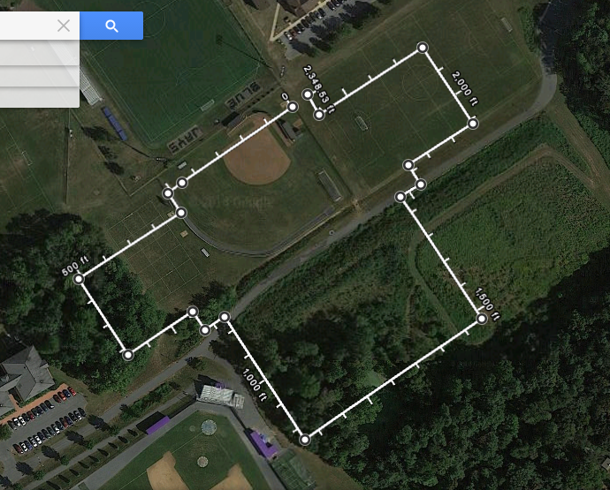
Fig. 1. Chosen site location with theoretical land usage and North orientation facing upwards.

APPENDIX B

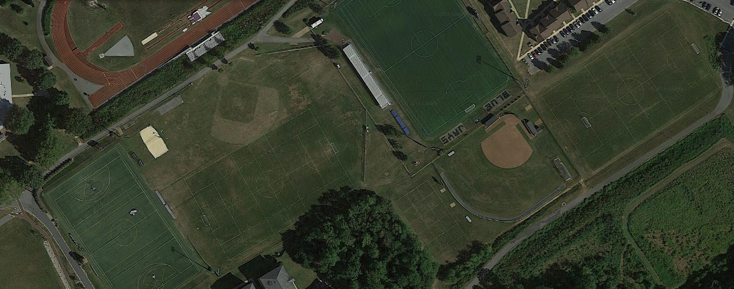
“Baseball” soccer practice field
Turf Multiuse Field
Soccer Varsity Field
Softball Varsity Field
“Quad” soccer practice field
Fig. 2. Current practice field layout

APPENDIX C

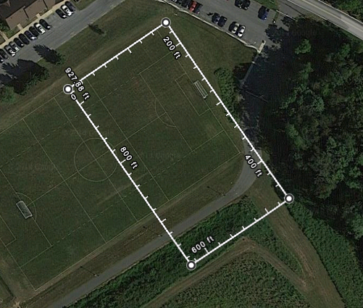
“Quad” Soccer Practice Field

Fig. 3. Repositioning of Quad Soccer Practice Field

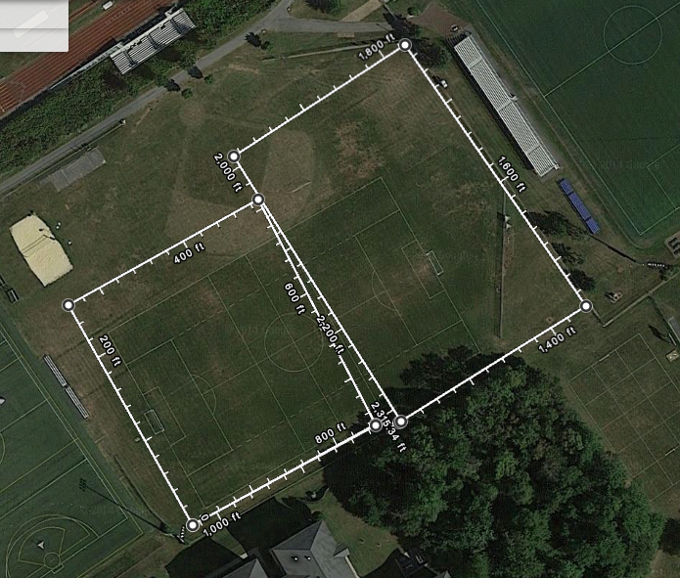
“Baseball” Soccer Practice Field
Softball Varsity Field

Fig. 4. Relocation of softball varsity field and repositioning of baseball soccer field

APPENDIX D

Fieldhouse
Jogging track | 33,000
NCAA track | 61,000 | X | 70,400
Additional seating | 75,000 | X | 94,860
Fitness & Wellness | 18,590 | O
Athletics Space | 22,000 | X | 6,300
Locker Rooms
Soccer (2) | Accommodate 35 | X | 3,000
Track & Field (2) | Accommodate 45 | X | 3,000
Visiting Teams (2) | Accommodate 45 | X | 2,800
Baseball (1) | Accommodate 35 | X | 3,000
Softball (1) | Accommodate 35 | X | 3,000
Sports Medicine
Trainer Facility | 2,730 | X | 3,200
Offices (2) | Unknown | X | 200
Equipment Space
Sports storage | Unknown | X | 3,150
Non-sports storage | Unknown | X | 2,100
Laundry | Unknown | X | 6,000
Multipurpose Room | 50 person classroom | X | 1,800
Office Space | Unknown | X | 1,800
X | Included and proper square footage provided
O | Not Included
X | Included, but undersized

APPENDIX E
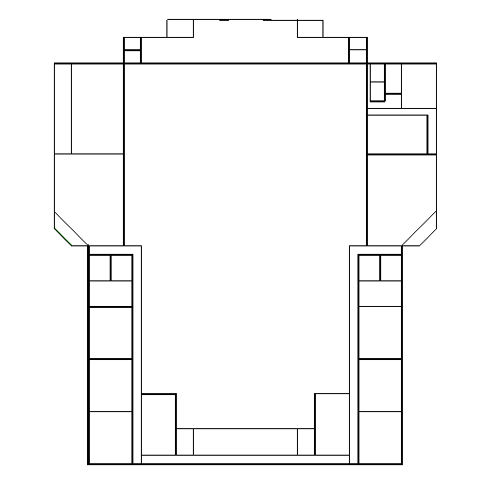

Fig. 5. Design One floor plan (Floor one)

APPENDIX F

Design One
500’ Max L x 440’ Max W: 203,800 sf

- 8 Lane, NCAA Regulated 200m Indoor Track
  - 60m Straightaway
  - 45m Pole Vault runway and pit
  - 45m Long Jump/Triple Jump runway and sand
  - High Jump space
  - Shot put area: 7,200 sf
  - Track area: 70,400 sf
- 2 Side Lobbies
  - 8,200 sf each = 16,400 sf total
- 1 Front Lobby
  - 13,600 sf
- 6 home team locker rooms
  - 3,000 sf each = 18,000 sf total
- 2 away team locker rooms
  - 2,800 sf each = 5,600 sf total
- 2 “Loop” and equipment rooms
  - 1,500 sf each = 3,000 sf total
- 4 public restrooms
  - 2 Men’s, 2 Women’s
  - 1,500 sf each = 6,000 sf total
- Ground floor walkway/viewing
  - Perimeters entire track
  - For team and spectator use
  - 22,360 sf
- Connecting Hallways
  - 8,500 sf
- Trainer/Wellness
  - 3,200 sf
  - 2 Offices: 200 sf each = 400 sf total
- Storage/Equipment Room
  - 3,150 sf
- Multipurpose Room
  - 1,800 sf
- 3 Flexible Office Spaces
  - 1,800 sf total
- Student services space
  - 8,400 sf
- Turf Room
  - 6,300 sf
- Additional Storage/Equipment
  - 2,100 sf
- Second floor viewing area
  - 2,100 sf

APPENDIX G

Fieldhouse
Jogging track | 33,000
NCAA track | 61,000 | X | 70,400
Additional seating | 75,000 | X | 94,860
Fitness & Wellness | 18,590 | O
Athletics Space | 22,000 | X | 33,600
Locker Rooms
Soccer (2) | Accommodate 35 | X | 3,000
Track & Field (2) | Accommodate 45 | X | 3,000
Visiting Teams (2) | Accommodate 45 | X | 2,800
Baseball (1) | Accommodate 35 | X | 3,000
Softball (1) | Accommodate 35 | X | 3,000
Sports Medicine
Trainer Facility | 2,730 | X | 3,200
Offices (2) | Unknown | X | 200
Equipment Space
Sports storage | Unknown | X | 3,150
Non-sports storage | Unknown | X | 2,100
Laundry | Unknown | X | 6,000
Multipurpose Room | 50 person classroom | X | 1,800
Office Space | Unknown | X | 1,800
X | Included and proper square footage provided
O | Not Included
X | Included, but undersized

APPENDIX H

Fieldhouse
Jogging track | 33,000
NCAA track | 61,000 | X | 70,400
Additional seating | 75,000 | X | 94,860
Fitness & Wellness | 18,590 | X | 27,300
Athletics Space | 22,000 | X | 33,600
Locker Rooms
Soccer (2) | Accommodate 35 | X | 3,000
Track & Field (2) | Accommodate 45 | X | 3,000
Visiting Teams (2) | Accommodate 45 | X | 2,800
Baseball (1) | Accommodate 35 | X | 3,000
Softball (1) | Accommodate 35 | X | 3,000
Sports Medicine
Trainer Facility | 2,730 | X | 3,200
Offices (2) | Unknown | X | 200
Equipment Space
Sports storage | Unknown | X | 3,150
Non-sports storage | Unknown | X | 2,100
Laundry | Unknown | X | 6,000
Multipurpose Room | 50 person classroom | X | 1,800
Office Space | Unknown | X | 1,800
X | Included and proper square footage provided
O | Not Included
X | Included, but undersized

APPENDIX I

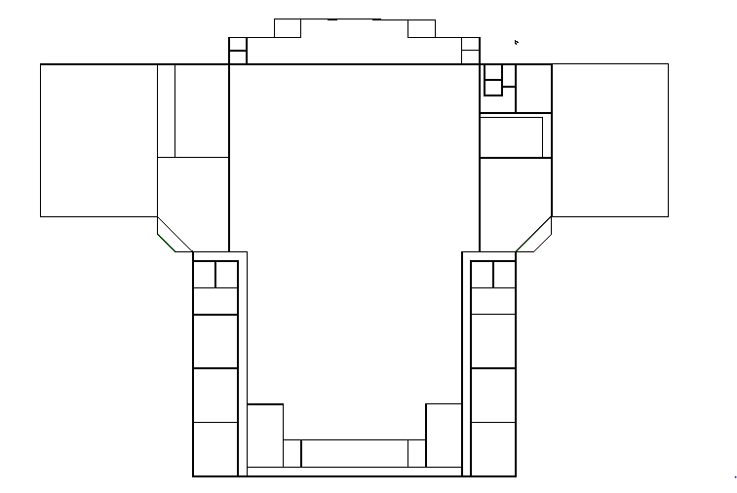

Fig. 6. Final design floor plan (Floor one)

APPENDIX J

Fig. 7. Layout of Design One, with North orientation facing upwards on the picture

APPENDIX K

A. Locker Rooms
The locker rooms are all the same setup and structure, and are shown in APPENDIX L. Table III shows the materials used. Ceilings are listed as N/A because the ceiling structure is open to the roof, allowing visible pipes and HVAC components to show.

TABLE III
Materials List

Body | Material
Walls | Brick with concrete interior
Ceiling | N/A
Roof | Standard roofing
Lockers | Wood
Floor | Tile/Carpet

B. Side Lobbies
TABLE IV
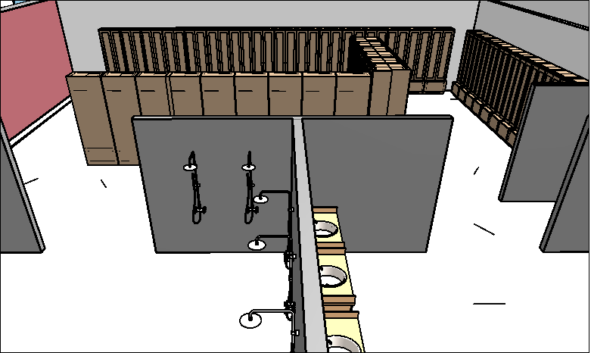
Materials List

Body | Material
Walls | Concrete/Curtain wall
Ceiling | N/A
Roof | Kalwall roofing
Floor | Concrete

C. Front Lobby
TABLE V
Materials List

Body | Material
Walls | Brick with concrete interior/Curtain wall
Ceiling | N/A
Roof | Kalwall roofing
Floor | Concrete

D. Main Fieldhouse
TABLE VI
Materials List

Body | Material
Walls | Brick with concrete interior
Ceiling | N/A
Roof | Kalwall roofing
Floor | Concrete with rubber track

E. Trainer Facility
TABLE VII
Materials List

Body | Material
Walls | Concrete
Ceiling | Standard Ceiling
Roof | N/A
Floor | Concrete

F. Loop Rooms
TABLE VIII
Materials List

Body | Material
Walls | Concrete
Ceiling | N/A
Roof | Standard roofing
Floor | Concrete

G. Right Wing
TABLE IX
Materials List

Body | Material
Walls | Brick with concrete interior
Ceiling | N/A
Roof | Kalwall roofing
Floor | Concrete

H. Left Wing
TABLE X
Materials List

Body | Material
Walls | Brick with concrete interior
Ceiling | N/A
Roof | Kalwall roofing
Floor | Hardwood

APPENDIX L

Fig. 8. Locker room configuration

APPENDIX M
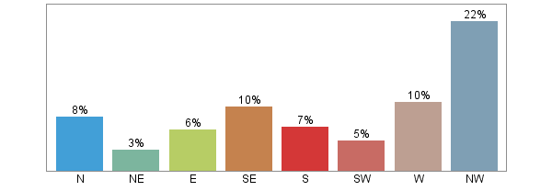

Fig. 9a. Wind direction bars [1]
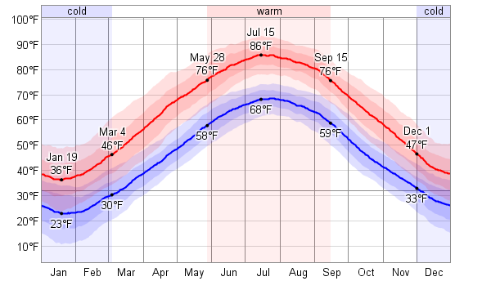

Fig. 9b. Temperature Averages [2]

APPENDIX N
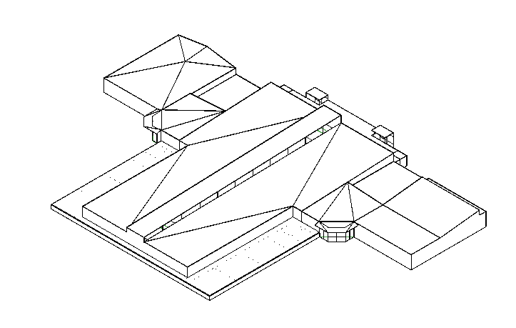

Fig. 10. Isometric view of final design, with extruded roof evident running down the middle of the main roof

APPENDIX O

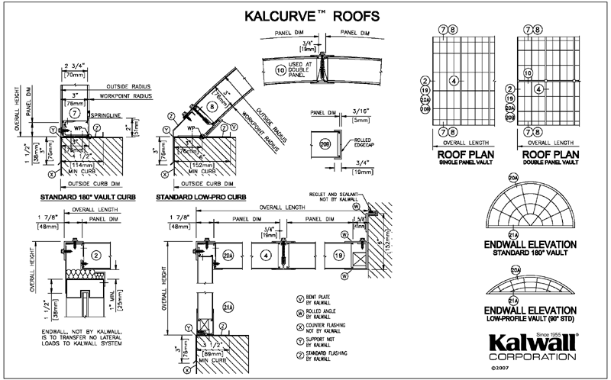
Fig. 11. Revit specifications for implementing Kalwall curved roof [3]

[4]
A SUMMARY OF SPECIFICATIONS for 2-3/4" (70mm) and 4" (100mm) unless noted.
Panel Width: 4' and 5' (1220mm and 1524mm) standard. Other widths from minimum 1' (300mm) up to 5'0" (1524mm) are optional and cost more.
Panel Length: 3' to 20' (914mm to 6096mm) standard, 16' max. (4880mm) for Skyroof® systems; lengths may be more limited for optional grid patterns; FM, windborne debris, and ATFP designs.
Panel Thickness: 2-3/4" (70mm) standards; and 4" (100mm) optional. NOTE: 1" (25mm) for window glazing only is custom. NOTE: Aerogel insulated panels are 2-3/4" (70mm) only.
Weight: Most panels and systems weigh under 3 p.s.f. (14.65 kg/m²).
Color: Standards are Crystal, White; Optional Kal-Tint faces; translucent insulation can be virtually any color to create dazzling results. White only available for extra-high-impact options.
Surface Texture: Flat is standard.
Standard Grid Patterns: Nominal grid size — 12" x 24" (300mm x 600mm) standard; 8" x 20" (200mm x 500mm) optional for flat and curved panels. Other designs and grid sizes available and may be required for some optional panel types. Please note that spans will vary with different grid patterns. Consult factory.
Materials: Translucent FRP faces. Other options include opaque faces, windows (HC2000 Thermal Break) (E-Series) and louvers, aluminum grid, composite grid, fiberglass or aerogel insulation, aluminum and thermally broken installation systems.
High-Performance Aluminum Architectural Coatings: Corrosion-resistant finishes in standard and custom colors. View color samples.
U-Value Range: .53 to .05 (U-value SI conversion: 1.0 w/m²k=0.176 Btu/(hr / ft² / °F)) for panels; NFRC system certification range .43 to .10. View NFRC values chart.
Light Transmission: 0 to 63%. View chart.
Solar Heat Gain Coefficient (SHGC): 0.10 to 0.65. View chart.
Impact: Standard exterior faces will withstand 70 ft.-lbs. impact. Optional hi-impact faces will withstand 230 ft.-lbs. (311J) impact. Hurricane-Resistant and Blast-Resistant Systems also available at even higher resistance.
Chemical Resistance: Most anything allowed by EPA and OSHA will not affect the standard panel systems.
Weathering: Kalwall's exterior face is made with innovative super-weathering and colorfast resins the full thickness... not a low-grade substrate overlaid with thin plastic film or gel to simulate weatherability. All standard exterior faces include a permanent glass-veil erosion barrier to prevent "fiber bloom"! This is just one built-in quality bonus not offered by look-alikes!
Sound: : 31 dB to 35 dB depending on panel thickness and insulation type.
Fire: Although some Kalwall panels contain combustible binder resins (ignition temperature greater than 800ºF), they will withstand a 1200ºF flame for one hour with no flame penetration (SWRI). Kalwall panels pass the Class "A" Burning Brand Test (ASTM E-108). A special configuration of Kalwall is a UL Listed Class A Roof system. All interior faces are 1 in. or less Burn Extent, by ASTM D-635. Several categories of interior and exterior flame-spread/smoke developed by UL 723 tunnel tests, including Class 1, are available. Kalwall is listed by: ICC #PFC-1705; several state and local areas and U.L. Canada, British Standard 476, Parts 3, 6, 7 and the European Technical Community; FM Class I and NFPA 268 – Radiant Panel Test-Exterior Walls. Whenever reference is made to fire tests, the numerical rating is not intended to reflect hazards presented by this or any other material under actual fire conditions.
Bond Strength: Panels are a specially engineered composite designed for maximum architectural and structural life. Panels and adhesives are tested according to the stringent requirements of "Criteria for Sandwich Panels" issued by ICC (International Code Council) and must pass severe tensile and shear tests before and after numerous exposure conditions. Before specifying an alternate, insist on actual field proof of bond integrity over a 20-year period. Caution is urged in accepting "look-alikes" as equivalents.
Expansion: The coefficient of linear thermal expansion of Kalwall is 1.24 x 10⁻⁵ in/in/ºF. (2.23 x 10⁻⁵ mm/mm/ºC). An 8' panel will expand lengthwise approximately 1/8" when the temperature rises 100ºF or a 2 m long panel will expand approximately 2 mm when the temperature rises 40ºC.

